ORIGINAL INSTRUCTIONS >EN





ROBOT LAWN MOWER

**FTDER22V1B/FTDER22V2B**

## USER GUIDE

CAUTION: Read this manual before using this machine!

**CONTENTS** EN

1. SAFETY INSTRUCTIONS 1
2. INTENDED USE 7
3. What’s in the box 7
4. TECHNICAL DATA………………………………………………………………………………….………………………………………….8
5. Preparing your lawn for the lawn mover 8
6. Installing the charging station 10
7. Laying the boundary wire 14
8. Operating the mower 15
9. Getting started: 17
10. Repairing the boundary wire....................................................................................................25
11. Replacing the blades...................................................................................................................26
12. TROUBLESHOOTING 27
13. Maintenance.................................................................................................................................27
14. Product Care................................................................................................................................28
15. DECLARATION OF CONFORMITY 29
16. WARRANTY 30
17. PRODUCT FAILURE 31
18. WARRANTY EXCLUSIONS 32

**1. SAFETY INSTRUCTIONS**

* **WARNING!** Before using this machine, please read this manual carefully and understand the instructions. Please keep these instructions for future use. If you give this tool to a third party, please also give this manual.
* Failure to comply with these safety rules is not only dangerous, but also voids the warranty conditions.
* Never allow children, persons with reduced physical or sensory or mental abilities, or no experience or knowledge, or persons unfamiliar with these instructions to use this machine. Local laws may restrict the age of the operator.
* Children should not be near the machine when it is in use.
* Do not let children play with this machine, whether it is in operation or not.
* Please ensure that the machine is in good working order. In case of damage or defect, do not use the tool and have it repaired by a qualified service.
* Never turn the mower on if it is turned over or if it is not in the working position.
* Switch off the machine when:
  + You do not use it,
  + When left unattended,
  + When performing an intervention on the machine,
  + When the battery fails,
  + During maintenance work,
  + When you transport the machine from one place to another.
* Keep children and animals out of reach of the machine.
* Before working, inspect the work area; remove any cables, stones, debris and any objects / materials from the area to be mowed that could cause an accident and damage.
* Avoid using the mower to cut grass that is not on the ground, for example, grass growing on walls or rocks, etc.
* Do not use the tool in the presence of flammable and / or explosive substances such as liquids, gases and powders.
* The operator is responsible for any damage caused to third parties within the work area.
* Mow only in daylight or with adequate artificial light.
* If you do not use the mower, store it in a dry place out of the reach of children.
* The mower must be used in accordance with these instructions and only in a vertical position relative to the ground. Any other position is forbidden because dangerous.
* Check regularly that the screws are correctly tightened.
* Before using the appliance and after any impact, check for signs of wear or damage and have the tool repaired if necessary.
* Never use spare parts or accessories not supplied or recommended by the manufacturer.
* Never allow children, persons with reduced physical, sensory or mental abilities or lacking experience or knowledge, or persons unfamiliar with these instructions to use this machine.
* Never use this machine when people, especially children or animals are nearby.
* Never replace non-metallic cutting means with metal cutting means.
* Do not touch dangerous moving parts before stopping the unit completely.
* Do not use the tool without guards.
* Never use the mower when it is raining. Do not expose it to water and moisture. Do not leave it outside during the night. Avoid cutting wet or damp grass.
* Familiarize yourself with the controls and proper use of the equipment.
* After the operation, perform the maintenance of the tool. Carefully follow the instructions in the chapter "Care and maintenance". These instructions will help keep the tool in good condition.
* Never replace non-metallic cutting elements with metal cutting elements.
* Do not expose the tool to rain or moisture.
* Do not use the tool when there is a risk of thunderstorms and lightning. Do not use the tool when weather conditions are poor.
* Do not insert metal objects into the charger or the battery connections, as this may cause a short circuit or be a source of danger.
* When the mower is in operation:
  + Do not open it and do not disassemble it
  + Do not carry repairs
  + Do not lift it
  + Do not check the blade
* Any inspection, repair, maintenance must be done completely off machine.
* Do not use the mower on slopes of more than 30 degrees max.
* Do not use the mower when its safety device is damaged.
* When the machine is no longer used, turn off the main switch and keep the appliance in a place out of the reach of children, to avoid damage to children or the lawn mower.
* The battery should always be charged when using the mower.
* Always use the battery and charger supplied. Do not use or mix these elements with other similar products. Incorrect use may result in electric shock, overheating, or leaking corrosive liquid from the battery.

**IMPORTANT**

**READ CAREFULLY BEFORE USE KEEP FOR FUTURE REFERENCE**

1. **Safe operating practices**

**Training**

a) Read the instructions carefully. Be familiar with the controls and the proper use of the machine.

b) Never allow people unfamiliar with these instructions or children to use the machine. Local regulations may restrict the age of the operator.

c) The operator or user is responsible for accidents or hazards occurring to other people or their property.

1. **Preparation**

a) Ensure the correct installation of the automatic perimeter delineation system as instructed.

b) Periodically inspect the area where the machine is to be used and remove all stones, sticks, wires, bones, and other foreign objects.

c) Periodically visually inspect to see that the blades, blade bolts and cutter assembly are not worn

or damaged. Replace worn or damaged blades and bolts in sets to preserve balance.

d) On multi-spindle machines, take care as rotating one blade can cause other blades to rotate.

1. **Operation**

**General**

a) Never operate the machine with defective guards, or without safety devices, for example deflectors and/or grass catchers, in place.

b) Do not put hands or feet near or under rotating parts. Keep clear of the discharge opening at all times.

c) Never pick up or carry an machine while the motor is running.

d) Remove (or Operate) the disabling device from the machine

- before clearing a blockage;

- before checking, cleaning or working on the machine.

1. **Additionally when the machine is operating automatically**

Do not leave the machine to operate unattended if you know that there are pets, children or people in the vicinity.

1. **Additionally when using the manual controller**

a) Mow only in daylight or in good artificial light.

b) Avoid operating the machine in wet grass.

c) Do not operate the machine when barefoot or wearing open sandals. Always wear substantial footwear and long trousers.

d) Always be sure of your footing on slopes.

e) Use extreme caution when reversing the machine towards you.

f) Always switch on the motor according to instructions with feet well away from the blade(s).

1. **Maintenance and storage**

a) Keep all nuts, bolts, and screws tight to be sure the machine is in safe working condition.

b) Check the grass catcher frequently for wear or deterioration.

c) Replace worn or damaged parts for safety.

d) Ensure that only replacement cutting means of the right type are used.

e) Ensure that batteries are charged using the correct charger recommended by the manufacturer.

Incorrect use may result in electric shock, overheating or leakage of corrosive liquid from the battery.

f) In the event of leakage of electrolyte flush with water/neutralizing agent, seek medical help if it comes into contact with the eyes, etc.

g) Servicing of the machine should be according to manufacturers’ instructions.

1. **Additional instructions**
2. Congratulations on the purchase of this exceptional quality product. For best results with your mower, read all of these features. This user manual contains important information regarding the specifications of this product, its installation and use.
3. Read this user manual carefully before using the automatic mower.
4. The mower may be damaged if not used properly.
5. Do not modify the original design of this mower. Any changes to this instruction manual will damage the mower and may cause accidents.
6. Check for stones, branches, tools, toys and other objects on the lawn that may damage the blades and stop the mower.
7. Never use a pressure washer or water to clean the mower.
8. Do not sit on the mower and do not use it as a means of transportation. Children and pets should be kept away from the lawn mower.
9. Turn off the mower before lifting or transporting it.
10. WARNING - Never allow children, people with reduced physical, sensory or mental abilities or lack of experience and knowledge or persons unfamiliar with these instructions to use the machine, local regulations may restrict the age of the operator;
11. WARNING - Do not allow children to be near or play with the machine during operation.

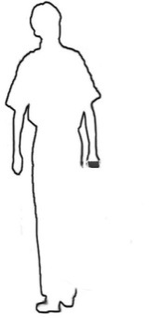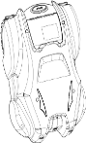

1. WARNING - Do not use the machine to create a hazard. Only use a machine in good working order, on grass, with a work area free of obstacles.

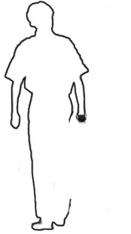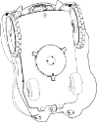

1. Persons who are inexperienced and / or have no knowledge of the instructions should not use this automatic mower (to avoid serious injury).
2. Do not place anything on the mower or its charging station.
3. Do not operate the mower with defective or damaged components such as blades, screws, nuts, etc.
4. Never put your hands and feet under the mower.
5. The mower does not guarantee full compatibility between the mower and other types of wireless systems such as remote controls, radio transmitters, electrified fences, etc.
6. Start the mower according to these instructions.
7. It is recommended that the cutting height be less than 7cm.
8. It is forbidden to use the mower on a lawn with a slope of more than 30 degrees.
9. Turn off the power before cleaning.
10. Carefully read all warnings on the machine, the battery, the charging station and in this manual.
11. Turn off the mower before transporting or repositioning.
12. Carry the mower by the handle at the back under the mower. Carry the mower with the blade disc away from the body.
13. Do not lift the mower by the outer protective case.
14. Turn off the mower and make sure it is completely shut down before performing any maintenance and cleaning.
15. Inspect the mower weekly and have damaged or worn parts replaced, such as blades or brushes. Any replacement of parts and accessories must be done by the manufacturer or an authorized after-sales service.
16. CAUTION: Do not touch the rotating blade. The blade must stop completely before handling.
17. Always check the baffle condition to keep the material discharge chute clean and unhindered.
18. Always use the battery supplied with this machine. In case of replacement, contact your dealer or the manufacturer for the type (s) of batteries that can be used with this machine.
19. Stop the machine by pressing the STOP button when you need to:
    * to remove a blocked item
    * check, clean or work on the machine.
    * Inspect the machine for damage after striking a foreign object.
    * Check the machine if it starts to vibrate abnormally. Check the damage before restarting;
20. The boundary wire must be disconnected from the docking station if it is damaged or intermingled. The mower must be extinguished before. the power plug of the adapter must be removed from the wall outlet.
21. Avoid using the machine and its peripherals in bad weather, especially in case of lightning, thunderstorms and generally in bad weather.
22. **Residual risks**

Even if you use this product in compliance with all safety requirements, the potential risks of injury and damage remain. The following hazards may occur in the structure and design of this product.

There is a risk of injury and damage to property due to attachments or broken the sudden impact of hidden objects when using cutting.

Risk of damage to personal injury and property caused by flying objects.

To reduce residual risk, always inspect the work area, wear safety shoes and protective equipment.

1. **Warning Label Descriptions**

|  |  |  |  |
| --- | --- | --- | --- |
|  | Warning/Danger! Do not play with this robot lawn mover. |  | Read the instruction manual. |
|  | Beware of severing toes or hands.  Do not put hands or feet near arotating blade. |  | Do not dispose electrical products  with general household waste.  Please check with your local  authorities for recycling advice. |
|  | Dangerous voltage |  | Press the STOP button before maintenance or lifting the machine. Read the instruction manual |
|  | Danger - risk of projection |  | Caution: Wait until blades stop rotating when switched off |
|  | Keep bystanders at a safe distance (at least 5m). |  | Do not ride on the mower or allow children or pets  to do so. |
|  | Pick up sticks, stones and foreign objects before using. |  |  |

**2. INTENDED USE**

This robot lawn mower is designed for mowing natural grass. Any other use is prohibited.

It is only suitable for private use in a garden or a plot. Lawn mowers designed for private plots or gardens are those used for the maintenance of grassy areas and private lawns.

Robot mowers work by making regular small cuts of the grass to maintain a set height. To do this they must be able to mow the grass multiple times per day every day. This will keep the grass level constantly in check. As it is cutting small amounts regularly the clipping will fall to the ground and are not collected. Over time these small clippings will compost and add nitrogen to the lawn. Eventually this will leave the lawn looking more green and lush and enhance the general health of the lawn.

**WARNING -** These types of mowers should not be used in public areas, parks, sports, agricultural or forestry areas.

**3. WHAT’S IN THE BOX**

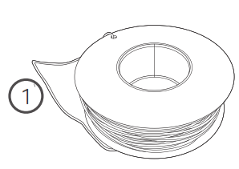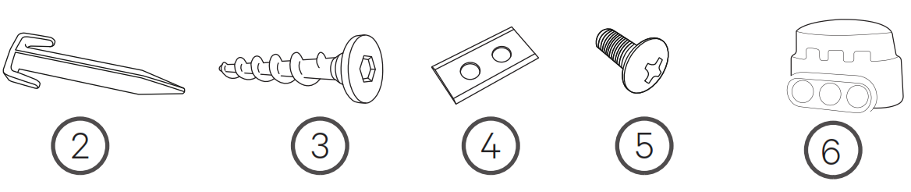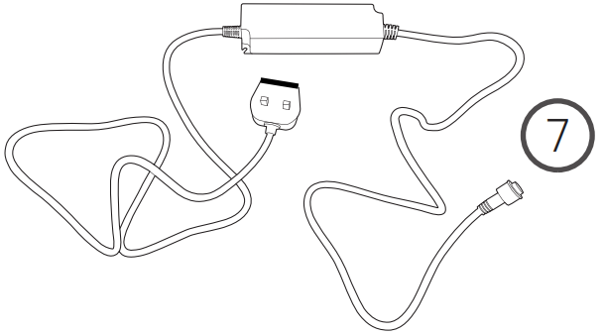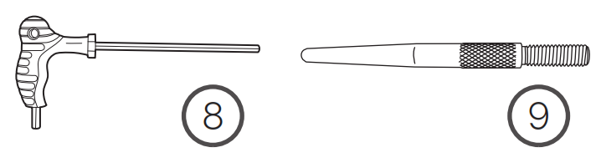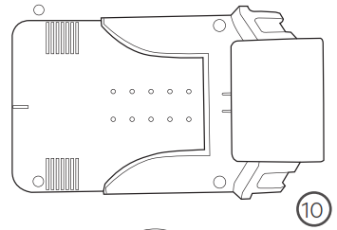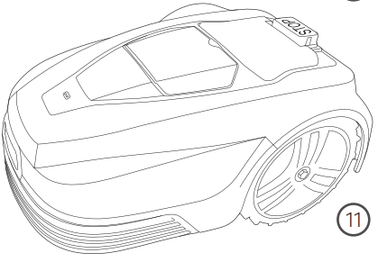

1. Boundary wire x100m/200m
2. Boundary wire pegs x120/240
3. Charge station groundscrew x4
4. Blades x9
5. Blade screws x10
6. Wire splicer x4
7. Power supply
8. Allen tool
9. Charging rods x2
10. Charging station
11. Robot Mower

**4. TECHNICAL DATA**

|  |  |  |
| --- | --- | --- |
| Model | FTDER22V1B | FTDER22V2B |
| Battery | Li-ion 22.2V/2600mAh | Li-ion 22.2V/5200mAh |
| Adapter | Input 100-240Vac, 1,5A max  Output 25.5V/2.0A | Input 100-240Vac, 1,5A max  Output 25.5V/2.0A |
| Frequency range: | 2412~2472 MHz | 2412~2472 MHz |
| Output power: | 14,05 dBm max | 14,05 dBm max |
| Blade motor speed | 3200~3500/min | 3200~3500/min |
| Working capacity | Max. 600m2 | Max. 1500m2 |
| Moving speed | 22 m/min | 22 m/min |
| Cutting height | 25-55 mm | 25-55 mm |
| Cutting width | 18cm | 18cm |
| Weight | 8.7kg | 9.0kg |

**5. PREPARING YOUR LAWN FOR THE LAWNMOVER**

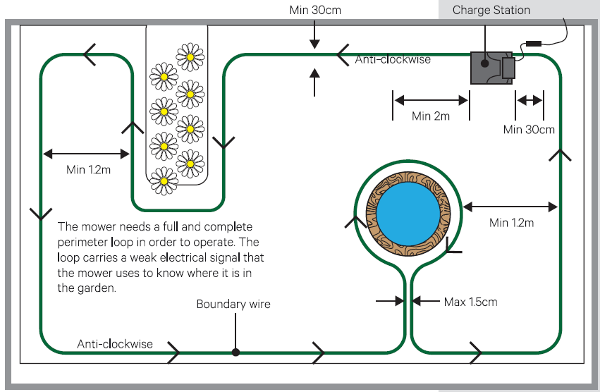

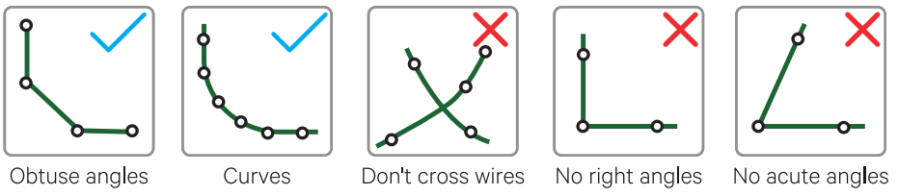

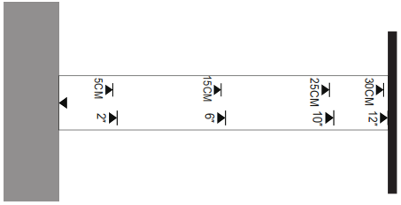

There is a handy ruler you can press out of the carton that will help you measure 30cm all around your garden

There may be parts of your garden which will be challenging or even impossible for your Robot Mower. Your Robot Mower will not stray beyond the boundary wire you must lay around your garden.

It will change direction on making contact with things like:

* + - Posts and poles (e.g. washing lines)
    - Fences and walls around trees

But it will need to be kept away from:

* + - Dug borders
    - Trees with exposed roots
    - Flower beds
    - Ponds and water features
    - Excessively uneven terrain.

The wire must be kept taut and never be allowed to loop or cross over itself. Ideally if ground is particularly uneven the wire can be buried up to 40mm deep and pegged down to secure. This can be achieved easily with a manual edging tool. If this is not desired or possible then the wire should be firmly pegged around the garden with pegs at a minimum of 1m intervals, keeping the cable taut to avoid it being cut by the mower, more so at corners and over uneven terrain.The cable should be positioned a minimum of 30cm from the edge of the garden, as the mower will overlap the wire, although it will not stray past it.

On corners the wire should not be laid at a sharp angle or right angle, but curved or a series of obtuse angles. The mower can detect a signal from the wire from as much as 18m away. It should be noted that due to this set up some areas of the lawn will not get mowed such as outside the perimeter edges. These can be maintained using a suitable grass trimmer.If the ground where the wires are to be laid is particularly dry and the soil hard from lack of rain, it will help to thoroughly water the garden before attempting to lay

your perimeter wire.

**Rectifying or avoiding problem areas obstacles such as tree roots on lawn**

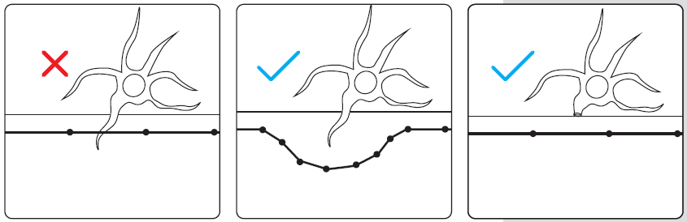

Alternatively, cut the tree

root back with a saw and

fill any resulting uneven

surface, then set the

perimeter over it

One solution is to take the

perimeter around the tree

root, leaving this area

unmowed.

If a tree root is protruding into the perimeter of your cutting area it would present a problem for the mower.

**Excessively uneven areas of lawn**

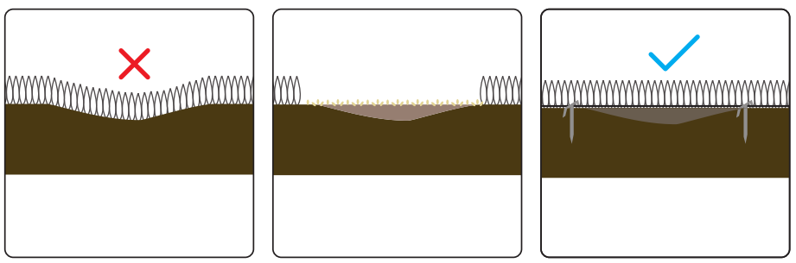

If the area is on the perimeter line this can be pegged out as normal.

If it is within the mowing

area it should no longer be a problem

If you don’t want to avoid

mowing this area, it’s best

to fill it with soil, compact

it down and re-seed it with

grass

A deep enough dip in the

surface of your lawn will

also present problems,

possibly causing the

mower’s wheels to lose

their grip and skid.

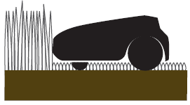

If your mower encounters particularly long grass it may treat it as an obstacle as it could bump the mower’s obstacle sensor. The grass needs to be at a reasonable level before the Robot Mower can function correctly

**6. INSTALLING THE CHARGING STATION**

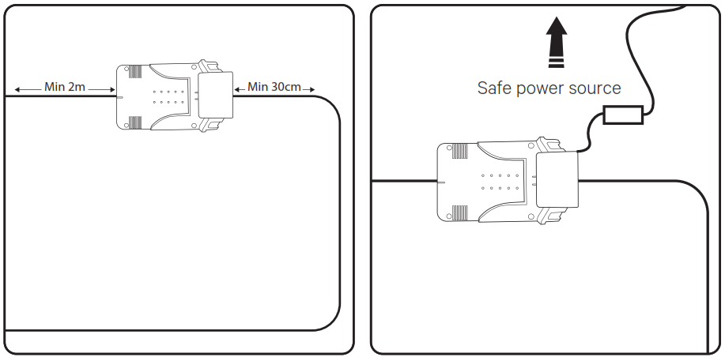

The location must be within 5m of a safe

power source – either a weatherproof

outdoor electrical socket or an indoor

power point in a garage, for example.

Ensure a minimum of 2m straight

perimeter from the front of the

charging station, and 30cm straight

from the rear.

The location of the charging station should be flat and secure, without risk of movement, if placed next to a border edge that is unstable it can slump

and cause the station to be uneven, this

will cause problems for the mower when

returning to charge.

Find a location with access to power, ensuring the mower can leave the charging station in an anti-clockwise direction. Don’t peg the plate down yet.

**WARNING:** Trailing wires are a trip hazard. Take care when choosing your location.

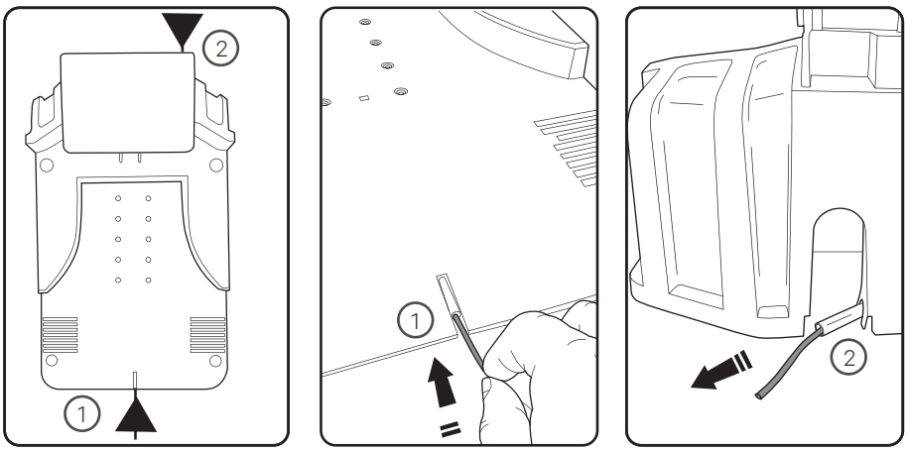

It will emerge at the rear of the unit (2).

Push the boundary wire into the tube at the front (1) of the charging stationt.

The boundary wire goes into the front (1) of the charging station and comes out at the back(2).

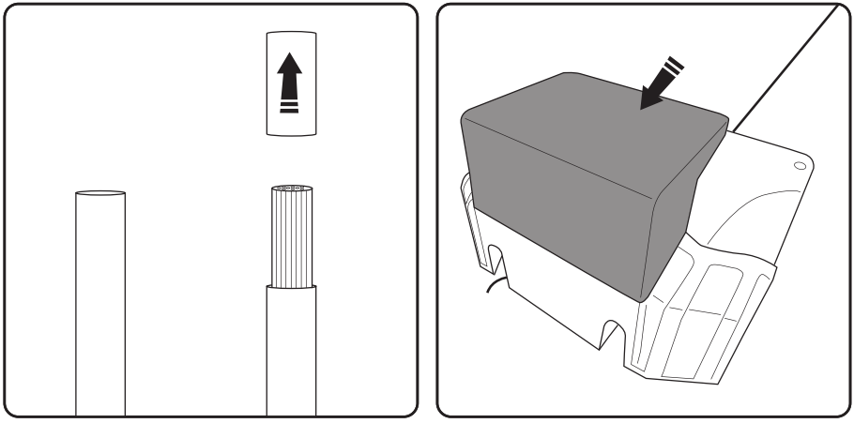

The charging stand has a hood at the back

(shown in grey) that hinges forwards.

You will need to strip the plastic sheath from the end of the wire before connecting.

Twisting the exposed wires after exposing

helps ensure a good connection.

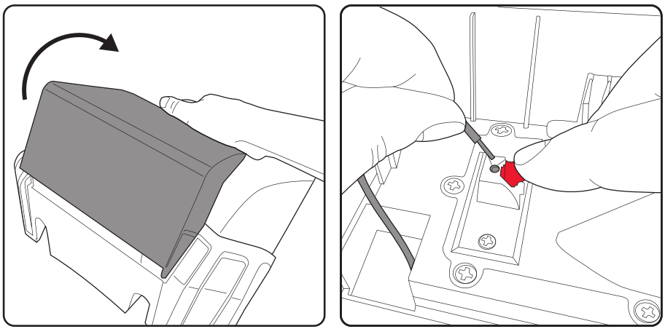

Push the charging station hood forward to uncover the wiring terminals.

The sprung terminal will need lifting to expose the hole, ensure the wire is full inserted before releasing the red terminal clip.

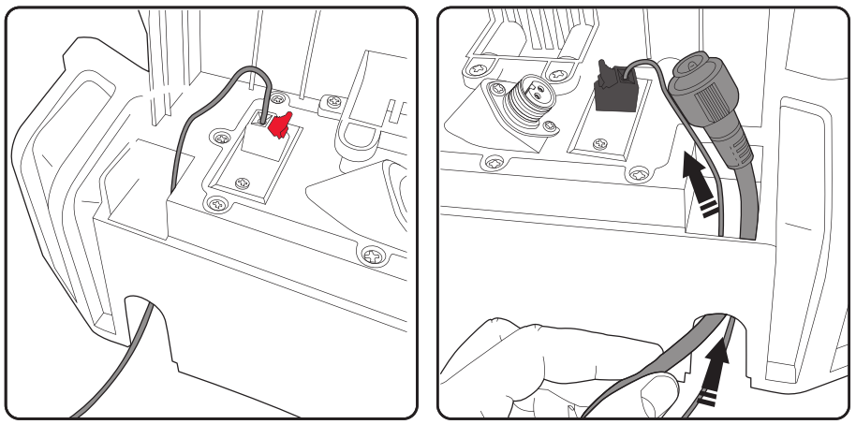

Feed the power lead up through the other side of the base station.

When you have completed your boundary wire it must return to the charging station and be fed up through the unit and plugs in at the black terminal.

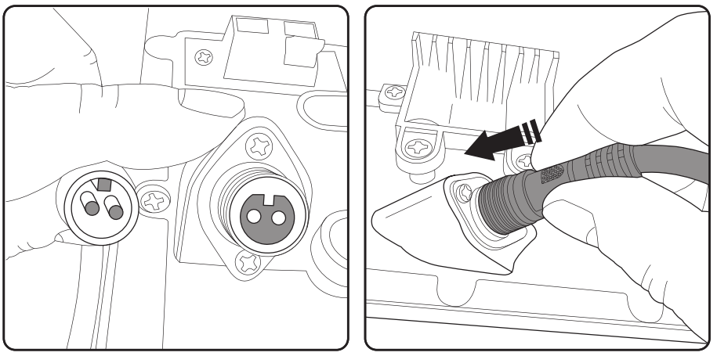

Then screw on the outer ring to secure the cable in place and prevent water ingress.

Push the power cable into place

Pay attention to the cable ﬁttings as there is a keyway orientation detail to ensure correct connection.

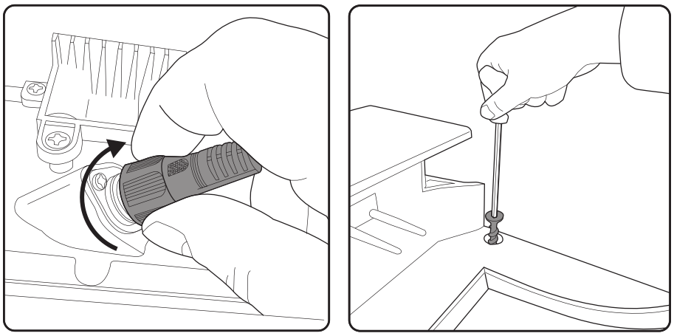

Once the base station has been fully wired, it can be secured in place with the four screws provided. Use the allen key provided to screw them in securely ensuring they are fully inserted and ﬂush with the station base. Protruding screws can hinder the mower from locating correctly.

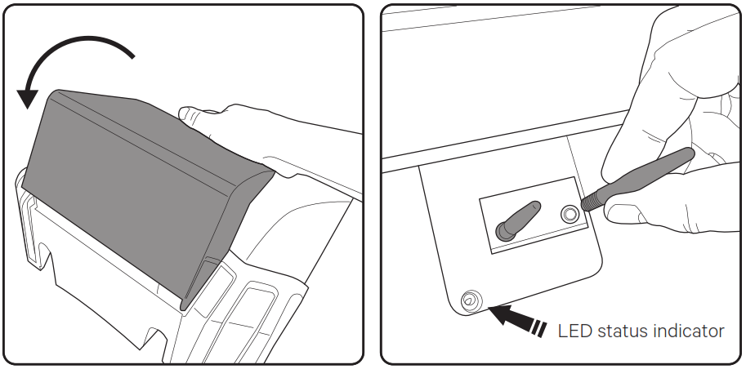

Making sure the power is switched o­ at the socket, screw the two charging rods into the holes just below the cover of the base station. Note: This is where the LED status indicator is situated. See page 22.

Push the cover back to its original position to cover the wires and connections from water ingress.

**7. LAYING THE BOUNDARY WIRE**

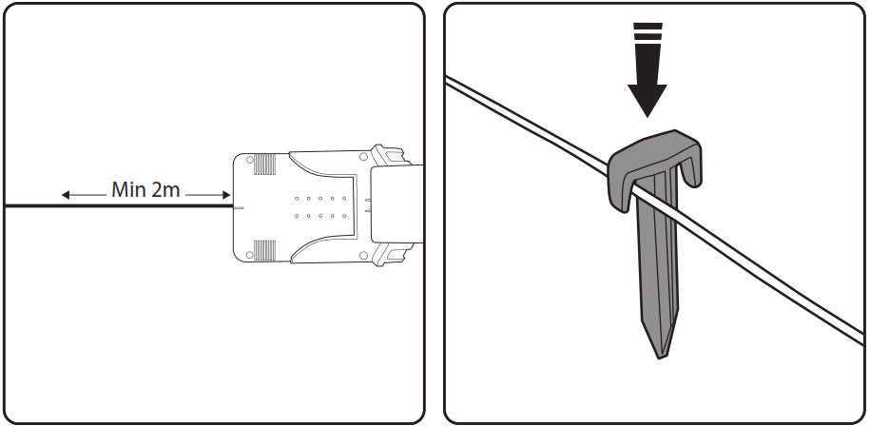

Keep the wire straight for at least the ﬁrst 2m. This is to allow the mower to return to the charging stand with ease.

Place the pegs at intervals of about 1m on straight and even ground, 30cm to 50cm on bends and corners. Uneven ground and obstacles will require more pegs.

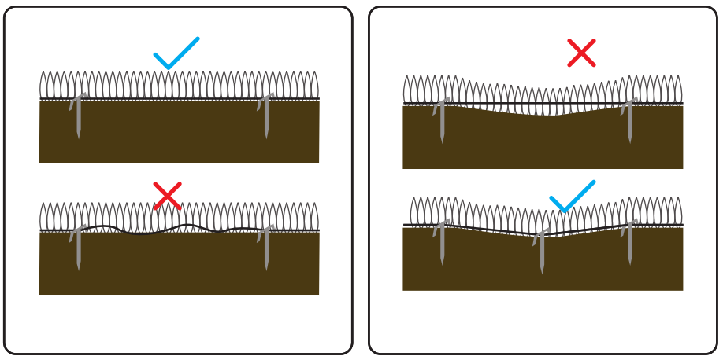

If the wire passes over a moderate dip in the lawn, more pegs will be required to keep the wire ﬁrmly pegged at ground level, or it risks being cut.

The perimeter wire must be kept tight. If it is loose it may well end up being cut by the mower as it passes over it.

**8. OPERATING THE MOWER**

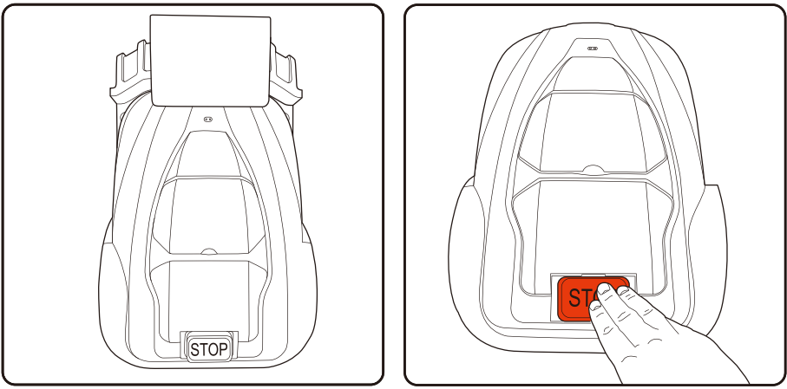

Press the STOP button

Place the mower on the base station with the wheels on the grips and the two pins engaged into the front of the mower. Note: the mower will require to be charged to at least 70% capacity before it will leave its station.

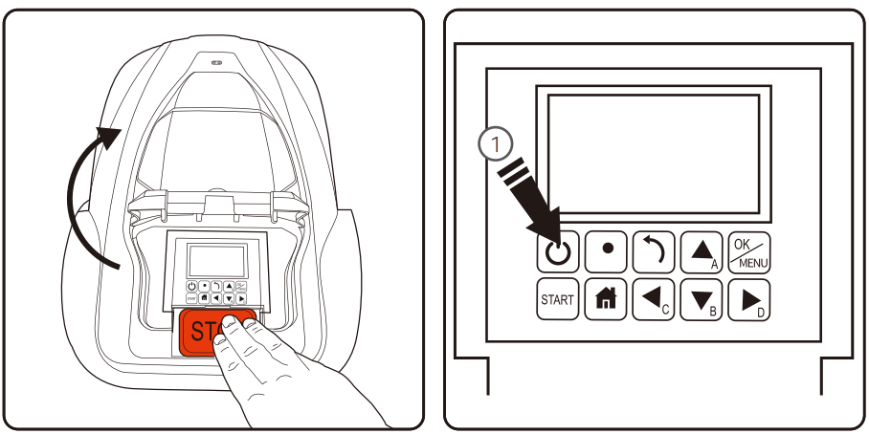

This will ﬂip open the control panel and LCD display cover.

Hold the power button (1) down for three seconds to activate the LCD display.

**Control panel**

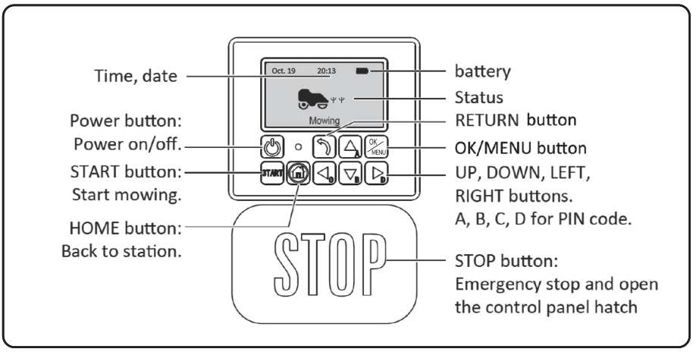

**Cutting height adjustment**

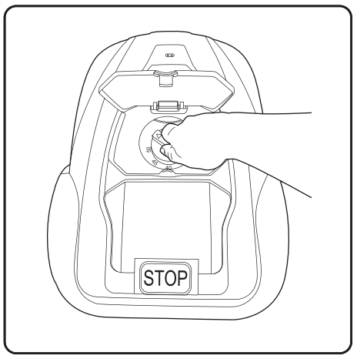

1. Open the knob lid.
2. Cutting height can be adjusted from 2.5cm to 5.5cm by rotating the adjustment knob.

**9. GETTING STARTED**

**Set the cutting height**

The ﬁrst cut of the season or long thick wet grass will need the highest setting (5.5cm). Gradually reduce to desired height once all ground has been covered. This may take a few days or a few weeks. If the perimeter wire is pegged to the surface of the garden rather than buried, it is a good idea to let the wire “bed in” to the surface of the lawn, during which time it is advisable to keep the mower on an elevated blade setting. NOTE during ﬁrst few days of mowing the grass may look stripy or patchy where the mower has covered /not covered. This is normal and will become even after several days once the full lawn area has been mowed.

**First time out**

The control panel will ask for setting a PIN code when the first time power on. Please remember the PIN code you set.

Pressing the start button and closing the ﬂap will cause the mower to start a perimeter circuit after which it will begin randomly mowing the lawn.

The ﬁrst few mows will appear random and unﬁnished, this is normal. With the multiple passes the mower makes over time, this will even out, and by using zoning and spiral spot mowing a desirable e­ect can be achieved in less time. These methods are explained on page 19 .

**New season mowing**

Between mowing seasons when the mower is not operating (during winter months) the grass can become unkempt and thickets emerge. On new season setup review mowing pass and address any problem areas.

|  |  |
| --- | --- |
| **Status** | **Meaning** |
| Standby | Mower is ready to work |
| Mowing | Mower is mowing automatically |
| Spot Mow | Mower is mowing spirally |
| Returning | Mower is going back to station |
| Charging | Mower is charging |
| Charge to work | Mower is charging and will continue program when charged |
| Emergency stop | Mower is stopped manually |
| Error | Mower cannot work |
| Firmware update | Firmware is updating |

**Power on Power off**

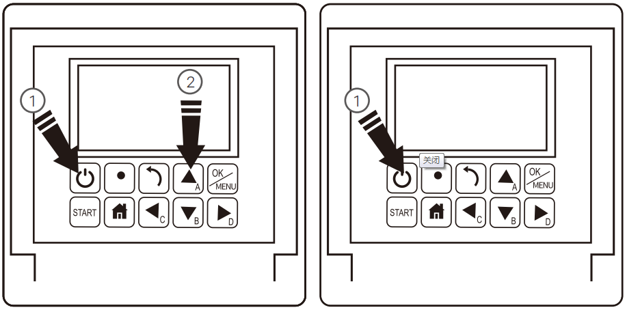

1. Press the power button for 3 seconds.
2. Press the power button for 3 seconds.
3. Enter the 4-letter PIN code you set.
4. The mower will now await further instruction in standby mode.

**Start mowing**

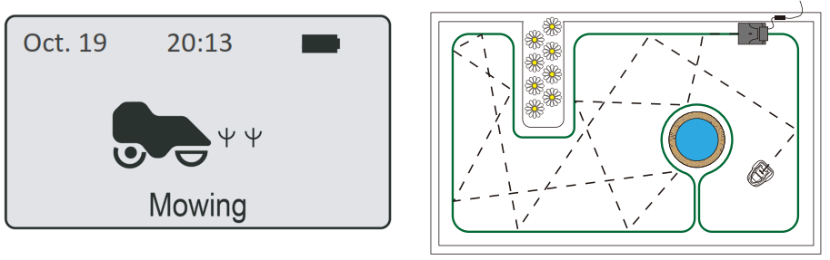

In standard mowing mode the mower will proceed in a random fashion around your garden, changing direction each time it reaches the boundary wire.

1. Press START button
2. Close the cover to start
3. Note: If the battery is below 70% charge, the mower enters ‘charge to work’ mode until it reaches 90% charge. If lower than 30% the mower returns to base station to charge.

**Work time setting**

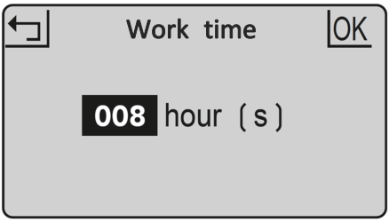

This is the amount of time the mower will be active. This includes charging time. For example: if set to 8 hours and the mower is set to operate from 8:00pm it will operate until 4:00am. In this time it may mow for 1 hour charge for 2 hours mow again for 1 hour; charge for 2 hours, mow for one hours and return to charge ready for the next cycle.

* + - 1. Press OK button to enter sub-menu 1.
      2. Select ‘setting’ to enter sub-menu 2.
      3. Select ‘work time’.
      4. Set work time by UP and DOWN buttons. (default is 8hrs)
      5. Press OK button to conﬁrm setting.

You may want to stop the mower during its cutting cycle. To do this:

**Stop Back to station**

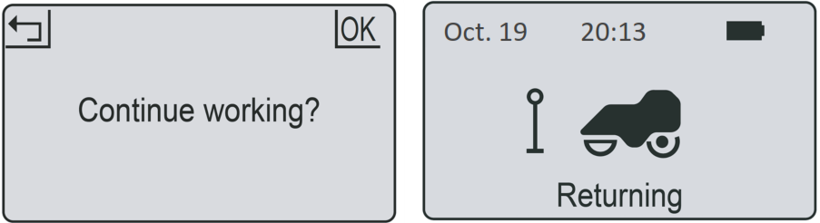

1. Press HOME button.
2. Close the cover and mower will return to station for charging.
3. Press the **STOP** button.
4. The mower stops immediately and the control panel hatch opens.
5. The screen shows **‘emergency stop’**
6. Press **OK** or **RETURN** button.
7. Enter the PIN code6.
8. If the mower was running when the **STOP** button was pressed, the screen will show ‘continue working?’. You can then either press **OK** to continue the task, or press **RETURN** to cancel it.

**Charging**

* + - 1. Place the mower in the station (or press HOME button)
      2. Mower will charge up to 100% and then go into standby.
      3. Mower will get charged again if battery is lower than 75%.

The mower charges on its station through the two charging rods. These insert into the front of the mower. Ensure the holes are free of debris or obstructions and that the mower aligns when approaching the charge station. Uneven ground on approach can cause the mower to not make a positive connection ﬁrst time. If this happens consider levelling the ground or moving the station to a more suitable area.

**Schedule**

* + - 1. Press **OK** button to enter sub-menu 1.
      2. Select ‘schedule’.
      3. Press **OK** button to select the desired day.
      4. Press **UP, DOWN, LEFT** and **RIGHT** buttons to set the start and end time.
      5. Press **OK** button to conﬁrm the daily setting.
      6. Repeat step 3 to 5 to complete the weekly plan.
      7. Press **OK** button to conﬁrm the weekly setting.

This allows you to change mowing schedules for di­erent days of the week, for example if you want to prevent mowing to occur on any given day or if other scheduled activity in the garden would prevent e­ective mowing during normal daily schedule.

**Zone**

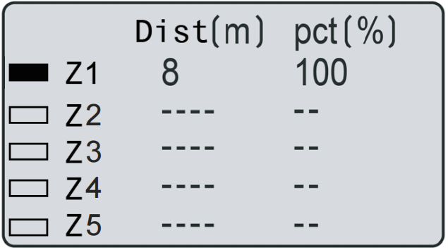 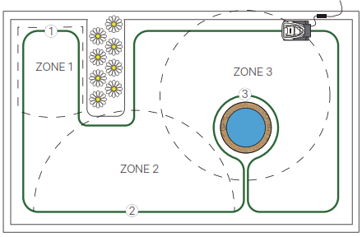

You can set up to 5 zones in your garden. This enables you to decide areas of your garden that need more or less attention. A zone is set by how far along the boundary wire from the base station. The distance should be 0 to 200m and the percentages should add up to 100% or the setting cannot be completed.

1. Press **OK** button to enter sub-menu 1.
2. Select **‘zone’**.
3. Press **OK** button to select the desired zone.
4. Press **UP, DOWN, LEFT** and **RIGHT** buttons to select the distance and percentage.
5. Press **OK** button to conﬁrm each zone.
6. Repeat step 3 to 5.
7. Press OK button to conﬁrm the setting of all the zones.

**Spiral mow**

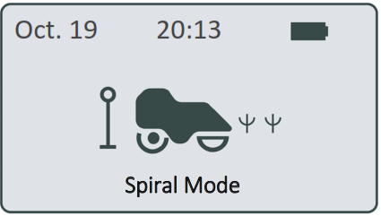 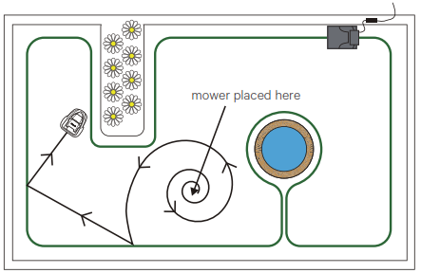

1. Place the mower in the garden.
2. Press OK button to enter sub-menu 1.
3. Select ‘Spiral mode’.
4. Close the cover to start.

The mower can be placed within the perimeter boundary and that the spiral mow.

function will mow in relatively uniform spiral pattern for 5 minutes. This is useful when you want to cover a speciﬁc area or clear grass on the ﬁrst mow more quickly.

**Edge Cutting**

* + - 1. Press OK button to enter sub-m enu 1.
      2. Select 'Setting' to enter sub-menu 2.
      3. Select 'Edge cutting'.
      4. Set the weekly execution frequency,1-5 times.( default is 3 times)
      5. Press OK to confirm setting.

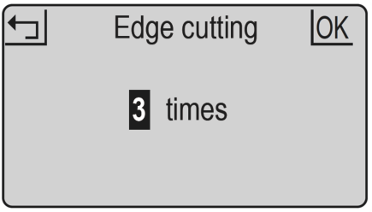

**Rain mode**

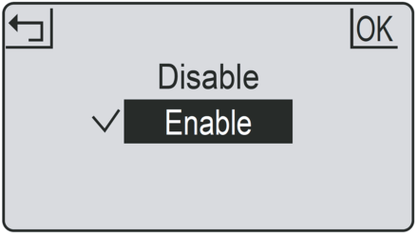

Rain mode sets if the mower will go out in rain or not. Disabling this will allow the mower to continue to work in the rain.

**WARNING**: avoid activation during heavy rain and storms. Wet grass will cause additional load for the mower and mowing time may be reduced. In some cases the mower may not return to the charge base in rain.

* + - 1. Press OK button to enter sub-menu 1.
      2. Select ‘setting’ to enter sub-menu 2.
      3. Select ‘rain mode’.
      4. Press UP and DOWN buttons to enable the rain mode.
      5. Press OK button to conﬁrm setting.

**Language Date and time**

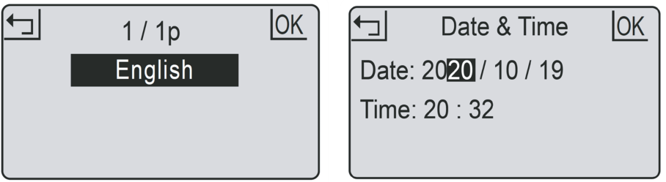

1. Press **OK** button to enter sub-menu 1.
2. Select ‘**setting**’ to enter sub-menu 2.
3. Select ‘**date & time**’.
4. Press **UP, DOWN, LEFT** and **RIGHT** buttons to set the date and time.
5. Press **OK** button to conﬁrm setting
6. Press **OK** button to enter sub-menu 1.
7. Select ‘**setting**’ to enter sub-menu 2.
8. Select ‘**Language**’.
9. Press **UP** and **DOWN** buttons to select the desired language.
10. Press **OK** button to conﬁrm setting.

**Setting date and time accurately ensures scheduling is accurate.**

**PIN code Change PIN code**

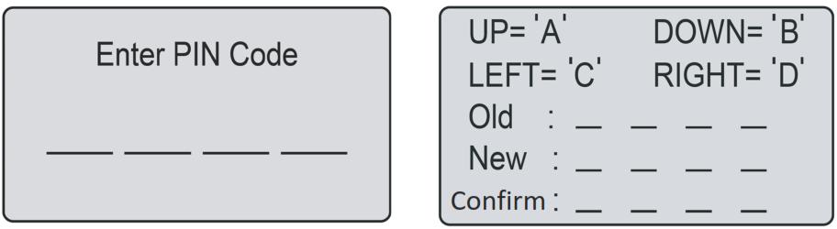

1. Press OK button to enter sub-menu 1.
2. Select ‘setting’ to enter sub-menu 2.
3. Select ‘information’ to enter sub-menu 3.
4. Select ‘error log’.
5. The past 10 records (including date, time and error message) will be shown.
6. Press **OK** button to enter sub-menu 1.
7. Select ‘**setting**’ to enter sub-menu 2.
8. Select ‘**Factory reset**’.
9. The screen shows ‘**Confirm to reset**?’
10. Press **OK** button to conﬁrm.
11. Press **OK** button to enter sub-menu 1.
12. Select **‘setting**’ to enter sub-menu 2.
13. Select ‘**change PIN**’.
14. Enter the original PIN code.
15. Enter new PIN code.
16. Enter the new PIN code again. (‘New passwords do not match’ will be shown for inconsistent passwords.)
17. Press **OK** button to conﬁrm.
18. PIN code should be entered after power- ing on, pressing **STOP** button, and before clearing error status and changing PIN code.
19. If the PIN code is incorrect, the screen will show “**PIN incorrect, please retry**’.
20. If the PIN code is entered incorrectly 3 times, the screen will be locked for 15 seconds. The lock time will double for further incorrect entries.

**Factory reset Error log**

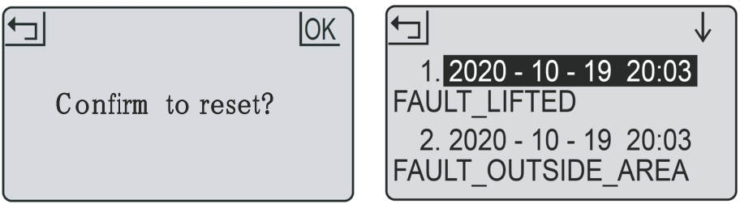

**In the event of malfunction the error log will record all actions and can be used for service maintenance and fault ﬁnding.**

**Work log Save power & LED indicator**

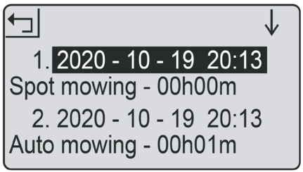

The backlight will switch after 2 minutes in the mower will power after 8 minutes, respectively, without user interference.

1. Press OK button to enter sub-menu 1.
2. Select ‘setting’ to enter sub-menu 2.
3. Select ‘information’ to enter sub-menu 3.
4. Select ‘work log’.
5. The past 10 records (including date, time and work mode and work time) will be shown.

|  |  |
| --- | --- |
| **LED on charge station** | **Status** |
| Solid red light | Broken boundary wire |
| Flashing blue light | Mower charging |
| Solid blue light | Loop signal normal or fully charged |

|  |  |  |
| --- | --- | --- |
| **Sub-menu 1** | **Sub-menu 2** | **Sub-menu 3** |
| Spiral mode |  |  |
| Schedule |  |  |
| Zone |  |  |
|  | Work time |  |
|  | Rain mode |  |
|  | WiFi setting |  |
|  | Change PIN |  |
|  | Date & time |  |
| Setting | Language | English |
| Norsk |
| Svenska |
| Dansk |
| ...... |
| Error log |
| Work log |
| About |
| Factory reset |  |
| Edge cutting |  |

**10. REPAIRING THE BOUNDARY WIRE**

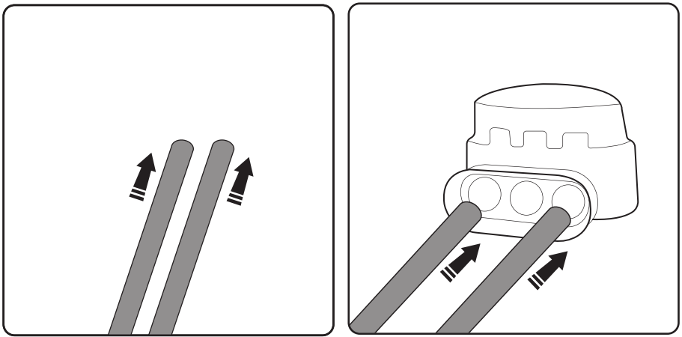

Taking a pair of pliers, crimp the metal tab onto the inserted wires. This will form a connection between the wires.

The clip has two channels in it. Push one end into one channel and the other end into the other. The wire needs to go right in.

If the boundary wire gets cut or breaks for any reason (indicated by solid red light on charging station), you need to locate and repair it. You will need to use one of the splicing clips provided. First take up the slack in the wire so there is some overlap.

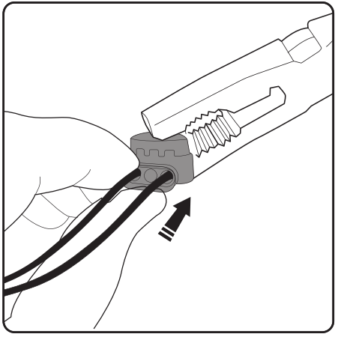

**When the boundary wire is repaired the charging station will display a solid blue light. If the light is still red there are more breaks in the loop, which will need locating and repairing.**

**11. REPLACING THE BLADES**

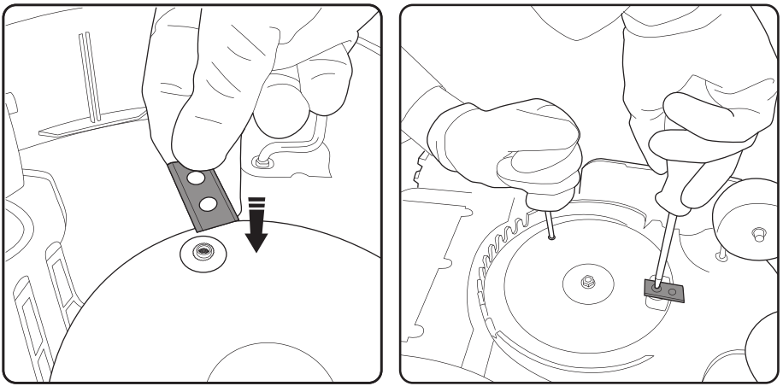

1. Use a second screwdriver to anchor the blade plate while you attach the blade.
2. Using a cross head screwdriver, secure the blade on the blade plate. The blade should be able to rotate freely once ﬁtted.
3. Repeat for other blades
4. Switch the mower o­ff
5. Wear protective gloves
6. Turn the mower upside-down
7. Place blade over raised screw-hole.

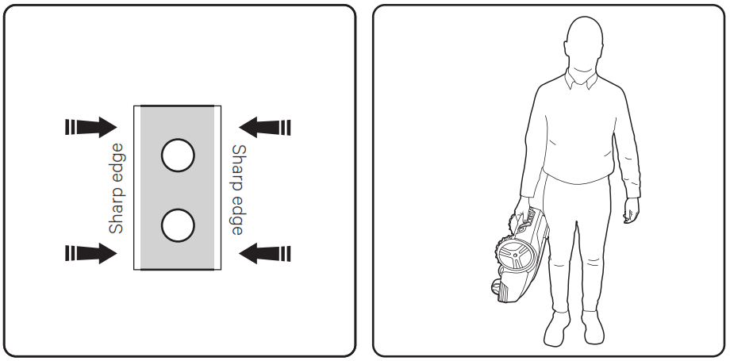

Re-orientate the blade (turn it around or turn it upside down) as each corner wears out until all four quarters of the blade have been used. If all four quarters have been used, then replace blade.

Carry the mower by the handle between the two rear wheels with the blades pointing outwards.

**12. TROUBLESHOOTING**

|  |  |  |
| --- | --- | --- |
| **Error message** | **Cause** | **Solution** |
| Mower outside | Mower is outside the perimeter. | Place the mower inside the perimeter. |
| Mower lifted | Mower is lifted away from the ground. | Move the mower to a ﬂat part of the lawn. |
| Mower tilted | Mower is tilted too much. | Move the mower to a ﬂat part of the lawn. |
| Mower overturned | Mower is upside down. | Return the mower to its normal position. |
| Mower trapped | Mower is trapped by obstacles. | Remove the obstacles. |
| Loop signal lost | Power supply or the wire is not connected to the station, or wire is broken. | Check the power supply, station and wire are connected normally. Identify wire break and repair with wire splicer. |
| Motor fault | Blade motor or drive motor is stuck. The motor current is too high. | Clear the grass or soil in cutting means and driving wheels. Cut the high and thick grass with a conventional lawn mower. |
| High temp | The battery temperature is too high. | The battery temperature is too high. |
| Battery abnormal | The battery is damaged. | Contact service center |
|  |  |  |

Wheel spinning faults where the mower will stop in a single spot and wheel(s) spin is a combination of uneven and/or wet ground. The solution is to add soil to level the ground. Ensure good drainage of the lawn before mowing, and not to mow during heavy rain and water logging.

If the boundary wires are in the wrong connectors (so the signal is clockwise not count- er-clockwise) then the mower will attempt to be outside the perimeter. If the mower leaves the area constantly then change the wires around at the charging station (moving the wire in red connector to black and vice versa).

**13. MAINTENANCE**

* + - 1. Check and clean mower regularly once a week.
      2. When you ﬁrst start using the mower, the blade plate, protections plate and blades should be checked once a month.
      3. It is important that the blades and blade plate rotate easily.
      4. Blade edges should not be damaged. Blade life depends on the type of grass, soil, lawn etc.
      5. Working with dull blades gives a poor mowing result, which needs more power to mow, meaning the mower covers a smaller area at a time.
      6. Charge the battery fully at the end of the season before winter storage. If storage time is longer than one year you will need to recharge the mower before use.

**Winter storage**

1. Mower must be carefully cleaned before winter storage. Charge the battery fully before storage.
2. Store the mower in the station and place in a dry area to protect from frost, preferably stored in the original packaging.
3. Boundary wire can be left in your lawn. As the charging station is removed you should protect boundary wire end from moisture with electrical tape.

**After winter storage**

* + - 1. Check whether the mower, boundary wire and charging rods need to be cleaned before use. If the charging strips appear to be rusty, clean them by using an emery cloth or suitable abrasive cloth. Check whether the mower time and date are setting correctly.
      2. Check whether the blades need to be changed.
      3. Check whether the blades and blade plate turn easily.

**14. PRODUCT CARE**

**Wear protective gloves when handling, cleaning or replacing the blade.**

**To reduce the risk of injury ensure that safety key is removed when the mower is not in use, being transported, handled or stored.**

**When the product has reached the end of its life, it and the Li-Ion battery it contains should not be disposed of with general household waste. The battery should be removed from the product and both should be disposed of properly at a recognised recycling facility.**

**FOR HOUSEHOLD USE ONLY**



Electrical products should not be discarded with household products. According to the European Directive 2012/19/EU on waste electrical and electronic equipment and its implementation into national law, electrical products used must be collected separately and disposed of at collection points provided for this purpose. Talk with your local authorities or dealer for advice on recycling.

**15. DECLARATION OF CONFORMITY**



BUILDER SAS

ZI, 32 rue Aristide Berges – 31270 Cugnaux - France

Declares that the machine indicated below:

ROBOT LAWN MOWER

FTDER22V1B/FTDER22V2B

Serial number: 20230135875-20230135944(FTDER22V1B)

20230135945-20230136014(FTDER22V2B)

Complies with the provisions of the Directive "machinery" 2006/42 / EC and national laws transposing it;

Also complies with the following European directives:

LVD Directive 2014/35/EU

EMC Directive 2014/30/EU

ROHS Directive 2015/863/EU

DIRECTIVE RED 2014/53/EU

Is also in line with European standards, with national standards and the following technical provisions:

EN 60335-1:2012+A11:2014+A13:2017+A1:2019+A2:2019+A14:2019

ETSI EN 301 489-1 V2.2.3 (2019-11)

ETSI EN 301 489-17 V3.2.4 (2017-02)

EN 55014-1:2017

EN 55014-2:2015

EN IEC 61000-3-2: 2019

EN IEC 61000-3-3: 2013+A1:2019

(IEC 61000-4-2; IEC 61000-4-3; IEC 61000-4-4;

IEC 61000-4-5; IEC 61000-4-6; IEC 61000-4-11)

ETSI EN 300 328 V2.2.2 (2019-07)

EN62311:2020

EN62233:2008

EN62368:2014+A11:2017

EN300328 V.2.2.2

Cugnaux, 01/01/2023



Philippe MARIE / CEO

Responsible of technical file: M. Olivier Patriarca





BUILDER SAS

32 rue Aristide Bergès - Z.I. du Casque - 31270 Cugnaux - France

MADE IN PRC